

First Year Experience
FC105
Course Title: FC105C New London: Then & Now
Credits: Three
ABE: Dominant Ability to be Assessed: Diversity & Global Perspectives - Level 1
Instructor: David Iscoe
Office Hours: By appointment, best availability Friday mornings and Wednesday afternoons, library.
E-mail: iscoe_d@mitchell.edu

Class time and room: 1pm-4pm Wednesdays, multiple locations as notified by email (check EMAIL!)
2:30pm-3:50pm Fridays, NH 203 or NH lobby or other location as notified by email (check EMAIL!)

Catalog Course Description: Mitchell is your COLLEGE and the City of New London is your CAMPUS! In this required first-year course, students will visit landmarks, museums, and other community sites. As students explore these community resources, they will develop an understanding of New London, both historically and as it exists now – a vibrant, diverse community which is ready to welcome them.

NOTE: FC105 must be taken in a student’s first two semesters at Mitchell and is a requirement for graduation. FC105 is waived automatically for a student who transfers in 24 or more credits from an accredited institution of higher education. Students may only take FC105 once.

REQUIRED COURSE TEXT AND RESOURCES: Podcasts, films, primary sources and open-source texts will be used in this course.
General College Policies
Civility: It is the right of every college student to be educated in an environment that is free of distraction from the educational activities being conducted in the classroom. To support a student’s right to a distraction-free educational environment, students engaged in any type of disruptive behavior will be asked to leave the classroom and will be counted as absent from the class.

Communication: Students are required to obtain and use a Mitchell College e-mail account for all departmental and College communications. All assignments/information will be posted as described by the instructor.

Attendance Policy: The Faculty of the College believes that in order for a college student to derive the maximum benefits of a course, regular attendance is necessary as is the punctual and adequate preparation of assignments. Please reference the Course Catalog for more information. However, each instructor may also have his/her own attendance policy.

The College ADA Statement (effective August 2021): Mitchell College complies with the mandates created by the Americans with Disabilities Act and Section 504 of the Rehabilitation Act. In accordance with these laws, Mitchell College is committed to ensuring that no otherwise qualified student, on the basis of their disability, will be denied access to course content, materials or activities.
A student, who believes they need accommodations, should contact the Office of Accessibility Services at 860-701-5790. Accommodations are not retroactive and cannot be provided by faculty based upon disability until the Letter of Accommodation has been issued by Accessibility Services. Letters of accommodation must be updated each semester. If students have questions or concerns, they should contact the Office of Accessibility Services. More information can be found in the Course Catalog and by visiting the Accessibility Services webpage at www.mitchell.edu/access.

Policy on Academic Honesty: Penalties and procedures regarding academic dishonesty are defined in the College Catalog. Academic dishonesty includes the following: using the work of another individual – including another student – as one’s own, using non-approved resources during quizzes or exams or submitting the same research paper for multiple classes. Please refer to the College Catalog for the procedure required when an instructor has evidence of Academic Dishonesty.

As described in the Mitchell College policy manual, “students at Mitchell College are expected to maintain the highest standards of academic conduct.” By enrolling in this course, students agree that they understand and swear to adhere to those rules. Failure to adhere to these rules will affect a student’s grades. Cheating and/or plagiarism on any assessment will result in a score of zero for that assignment and the incident will be reported to the academic dean. Cheating on the final exam will result in course failure.

Grading Scale: THIS COURSE IS PASS/FAIL. SEE GRADING POLICIES BELOW.

Departmental Policies

Attendance Policy: Attendance and participation are critical to learning. You are expected to attend class on time and engage in all class activities. If you are unable to attend class, you are expected to make up the class time with your professor.

Make-up Policy: It is important to stay on top of indicated due dates as much of the work in this course builds upon earlier assignments. As always, it is in your best interest to communicate with your professor and reach out for help if you are struggling to manage assignment expectations and/or deadlines. See course outline for deadlines.

Accommodations: Please inform the instructor of any accommodations required. See the College ADA Statement (effective August 2021) above for details.

Departmental E-Mail /Communications requirement: Contact with your instructor is essential. If you must miss class for any reason, it is your responsibility to contact the instructor.

Plagiarism: Plagiarism is the unacknowledged use of another person’s words or ideas in your writing. If you use any ideas, thoughts, writing, quotes, or even paraphrase some other writer’s thinking, you must acknowledge that person. Whether conscious or unconscious, plagiarism is a serious academic offense. Consequences for plagiarism can range from failing the assignment to failing the course. Please familiarize yourself with the college’s policy. You can access the policy as well as resources to help you avoid plagiarism on the library’s plagiarism guide at http://mitchell.libguides.com/CW101.

Classroom Participation:
In addition to regular attendance, students are expected to be prepared for each class, submit assignments on time and actively participate in class discussions and activities. It is expected that you will prepare thoroughly, keep up with the work, and participate fully and actively in all class activities. Classroom decorum during the instructional process is based on mutual respect: instructor for student, student for instructor, and student for student. Be on time. Be prepared. Pay attention and participate for the full class period.

Writing Standards:
All written work is to be handed in via Open LMS (Moodle) unless your instructor directs otherwise. For All Writing Assignments: Conventional Manuscript Format & Basic Conventions of Standard Written English are Required

- Typed and Printed or Uploaded to Moodle
- Keeps 1” margins all around
- Uses Times New Roman script
- Uses 12 Point Font
- Numbers pages beginning with page 2
- Uses complete sentences
- Uses appropriate language
- Uses standard grammar and spelling (contains no texting language)
- Shows evidence of proofreading
- Uses own words and thoughts and gives credit to the words and thoughts of others as appropriate

Ability Based Education
ABE partners the intellectual abilities cultivated by the liberal arts and sciences with the professional skills and personal development required to compete in the global economy. As students’ progress through their programs of study, they will collect evidence (papers, videos, presentations, projects, etc.) that document their level of mastery. There are three levels of mastery:
1. Developing
2. Competent
3. Distinguished

Students must achieve at least Level 2, Competent, in 5 of 7 abilities. The seven abilities to be assessed prior to graduation from Mitchell College are:
- Critical & Creative Thinking
- Communication
- Diversity and Global Perspectives
- Information and Communication Technology Literacy (ICT Literacy)
- Problem Solving and Analysis
- Values, Ethics & Social Responsibility
- Social Interaction
Course-Specific Information

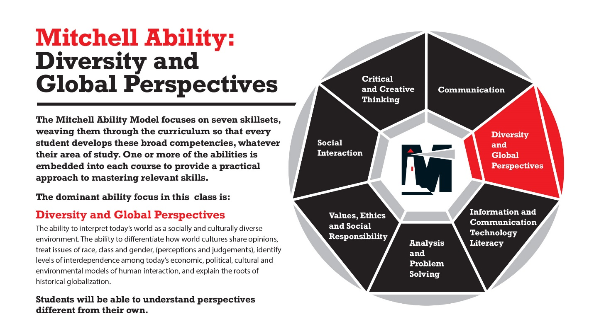
Outcomes:

FC 105 LEARNING OUTCOMES  Each student will… | ABE OUTCOMES – Diversity & Global Perspectives L1  Each student will:
Understand themselves as members of the broader New London community. | Demonstrate a Willingness to Appreciate Cultural Differences
Explore the vibrancy and diversity of the New London community. | Identify and Understand One’s Own cultural Norms and Biases
Investigate the cultural, economic, political, and environmental history of the New London community. | Demonstrate an Understanding of Cultural Worldview Frameworks.
 | Analyze Communication within Cultures

Grading:

FC105 is graded pass/fail.

Passing FC105 New London: Then & Now is a requirement of the Mitchell College curriculum. Students will sign a contract that agrees to the following:

In order to pass FC105, I need to demonstrate that I have achieved each of these outcomes:

1) I will understand myself to be a member of the broader New London community.
How I will demonstrate this? I will complete a “My New London Project” which I will present to the class.

2) I will explore the vibrancy and diversity of the New London community.
How I will demonstrate this? I will complete the New London Scavenger Hunt activity.
3) I will investigate the cultural, economic, political, and environmental history of the New London community. How I will demonstrate this? I will write and/or mind map in a weekly journal, which I will show to my professor and/or my fellow students each week in class.
Additionally, I understand that I must attend EVERY class.

If I do have to miss a class, I will:
1) Inform my professor ahead of time and,
2) Arrange to make up the class with my professor.

These contracts will be signed on the first day of class.

SPRING SEMESTER 2026 CALENDAR

SPRING 2026 January 18 Sunday All students move in/check in January 19 Monday Martin Luther King, Jr. Day – College Offices Closed January 20 Tuesday 1 st day of classes, Spring Semester - Add/Drop begins January 27 Tuesday Add/Drop ends at 5:00pm (6 days) January 30 Friday Student Attendance Census Mandatory Reporting by Faculty February 9 -13 4 th Week February 13 Friday Presidents’ Day Recognition – No Classes - College Offices Closed February 16 Monday Presidents’ Day – Classes in session February 16 Monday EARS due to Registrar by 9:00 a.m. March 3 – 7 7th Week March 6 Friday Last day of classes before Spring Break March 6 Friday Mid Term Grades Due to Registrar by 9:00 a.m. March 9-13 Spring Break for Students (Res. Halls close on Friday March 6 at 5:00 pm and reopen on Sunday, March 15 at noon) March 30 Monday F26 Registration begins April 3 Friday Last Day to Withdraw from a Class Academic Year 2025-2026 College Calendar This Academic Calendar attempts to present information as accurately and completely as possible. Mitchell College reserves the right to change any of the dates and/or events if deemed necessary. For dates of Admissions events (open houses, accepted students events, orientations), please visit the Mitchell College Master Calendar. 10/21/2024 v.2 rumrill April 10 Friday F26 Registration ends April 22 Wednesday Campus Honors and Awards Ceremony ~ 4:00 p.m. May 1 Friday Last day of classes before final examination period May 2 & 3 Sat-Sun Reading Days May 4 - 8 Mon-Fri Final Examination Period May 8 Friday Residence Halls close at 5:00pm May 2 Saturday Thames Celebration at 10:00 a.m. May 11 Monday Final Grades Due to Registrar by 9:00 a.m. May 16 Saturday Commencement at 10:00 a.m.Class Schedule:
Wednesdays at 2:30pm starting January 23rd, Fridays at 1pm starting January 28th. Visit locations will be determined as the semester goes on.
Potential locations include
Washington Street Coffee House
Custom House Maritime Museum
Fiddleheads Food Co-Op
Ocean Beach Park
Seaside Sanatorium
New London Union Station
Pequot Chapel
Tantaquidgeon Museum
Jake’s Diner
Shamrock Auto
Red Square Art Museum
Caroline Black Gardens
Lyman Allyn Art Museum
Connecticut College Arboretum (Native Plants Collection)
Magik Press Studios / Harris Place Atrium
The Annex
The Golden Owl
Flavours of Life
Telegraph Autonomous Zone (record store)
Fort Trumbull
FRESH Community Gardens
New London Black Heritage Trail / Freedom Trail Neighborhood
City Hall
And others – we won’t get them all, but we’ll go based on need and possibility.

Community Expectations:
Reserve phone use for taking photographs during field trips
Dress appropriately for field trips – wear layers, cold weather protection, and/or sun protection as needed, and bring a water bottle.
Interact with your environment respectfully
Advocate for yourself and your learning
Respect visitors to the classroom
Share accessibility needs with your instructors, including mobility needs, food allergies, and environmental allergies
Reserve phone use for taking photographs during field trips
Dress appropriately for field trips – wear layers, cold weather protection, and/or sun protection as needed, and bring a water bottle.

My New London Final Project Instructions:
Chart your journey through the class – take pictures and notes. You’ll be asked to remember key points (and the more photos you have, the better and easier your final presentations will be).
Put your heart into these. It’s a chance to show what’s real to you (and entertain your classmates).
Students in good standing (zero missed classes / missed participations, and/or all missed classes/participations made up) will be able to present their final EARLY and will not have to attend during finals week.

